Model - It is the data of the component. For example, if we take a Button, the text in it is a model.
View - The look (a.k.a. the visual appearance) of the component.
Controller - The controller sends commands to update the model and/or the view.

Let us consider a practical example, take a Text field. It is a GUI component that is visible to your eye. When you create and add it to a frame and present it to the user, the user is able to see it and write text in it.

The user is able to see it - So it is a view. He is able to see the white background, border, text in it.

The user is able to update the text in it - So it is a model. Now, don't consider the appearance, only the text, the data. When you call getText() after the user has typed some text in it, you get what he has typed. So, model represents the data in the component.

When the user types, he is able to update the text in it (the model) as well as the visual appearance (the view -- whatever he types is displayed in the text field) - So it has a controller that is responsible for the model and the view being updated.

Now, what is MVC Architecture in total, all these three are separated to maintain cleaner code. The advantage of this is that you can plug in the look and feel you want without having any side effects on the GUI component, either on its data or the way it functions.

Swing Architecture
Swing is platform independent and enhanced MVC (Model –View – Controller) framework for Java application. Here are the most important features in Swing architecture.
- Pluggable look and feel: Swing supports several look and feels and currently supports Windows, UNIX, Motif, and native Java metal look and feel. Swing allows users to switch look and feel at runtime without restarting application. By doing this, users can make their own choice to choose which look and feel is the best for them instantly.
- Lightweight components: All swing components are lightweight except some top-level containers. Lightweight means component renders or paints itself using drawing primitives of the Graphics object instead of relying on the host operating system (OS). As the result, the application presentation is rendered faster and consumed less memory than previous Java GUI applications.
- Simplified MVC: Swing uses simplified model-view-architecture (MVC) as the core design behind each of its components called model-delegate. Based on this architecture, each swing component contains a model and an UI delegate. A UI delegate wraps a view and a controller in MVC architecture. UI delegate is responsible for painting screen and handling GUI events. Model is in charge of maintaining information or states of the component.
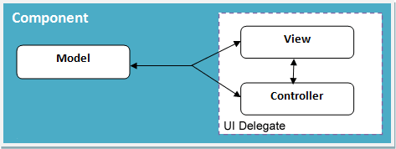
Java Swing MVC – Model Delegate

